Smart File Organizer Using Linked List

Problem Statement:
Managing a large number of files and folders can be difficult when their names are not organized properly. Finding a particular file, adding new entries, or removing unnecessary entries may take time. Traditional methods of storing data in fixed-size arrays are less flexible when the number of entries changes frequently.
The Smart File Organizer using a Linked List is a C++ application designed to store and manage file and folder names dynamically. It uses a singly linked list in which each node stores a file or folder name and a pointer to the next node. This structure allows the user to add new entries without specifying a fixed size in advance.
The system provides various operations, including inserting new file or folder names, displaying all stored entries, searching for a particular entry, deleting an existing entry, and counting the total number of entries. These operations help users understand how linked lists can be used to organize and manage dynamically changing data.
The main purpose of this project is to demonstrate the practical application of linked lists, pointers, dynamic memory allocation, and basic data-structure operations using C++. The current version manages names in program memory and can be extended in the future to interact with actual files and folders on the computer.

Objectives :-
To develop a Smart File Organizer using C++ and a singly linked list.
- To store file and folder names dynamically using linked-list nodes.
- To insert new file or folder names into the list.
- To display all stored file and folder names.
- To search for a particular file or folder by its name.
- To delete a specific entry from the list.
- To count the total number of stored entries.
- To understand the concepts of pointers, dynamic memory allocation, and linked-list operations.
- To manage a changing number of entries without requiring a fixed-size array.

Algorithm:
Step 1: Start the program.
Step 2: Initialize the head pointer to NULL.
Step 3: Display the menu with the following operations:
- Add a file or folder name
- Display all entries
- Search for an entry
- Delete an entry
- Count total entries
- Exit
Step 4: Accept the user's choice.
Step 5: Perform the selected operation:
- Add: Create a new node, store the file or folder name, and insert it into the linked list.
- Display: Traverse the linked list from the head and display all entries.
- Search: Traverse the list and compare each name with the required name. Display whether it is found.
- Delete: Search for the required name and remove its node from the linked list.
- Count: Traverse the list and count the total number of nodes.
- Exit: Stop the program.
Step 6: If the user does not select Exit, return to Step 3.
Step 7: Free the allocated memory before terminating the program.
Step 8: Stop.

Flowchart:
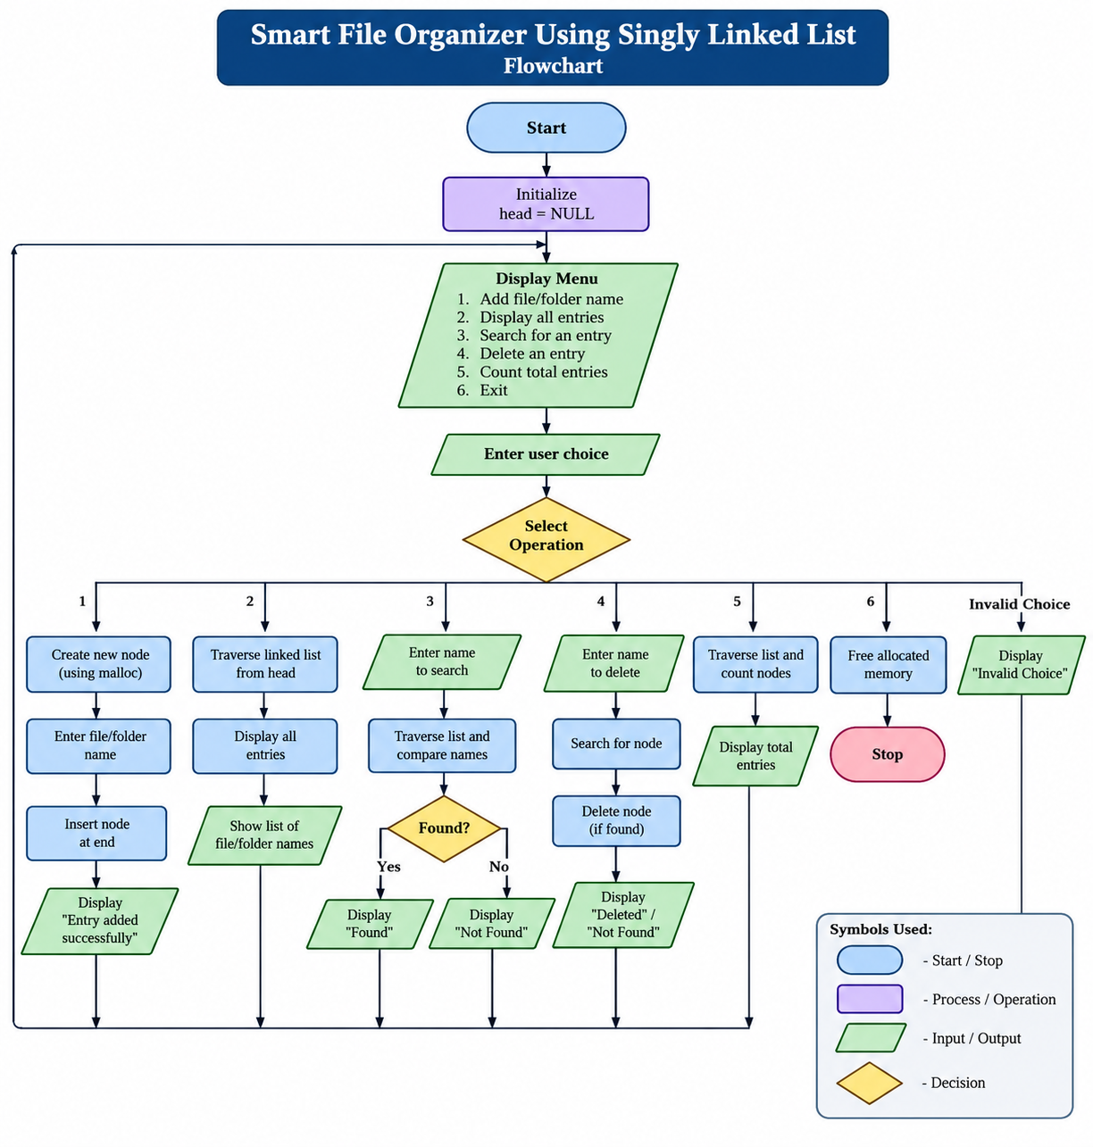

Conclusion:-
The Smart File Organizer Using Singly Linked List project demonstrates how linked lists can be used to store and manage file and folder names dynamically. The system allows users to add new entries, display all entries, search for a particular name, delete an entry, and count the total number of entries.This project helps in understanding important concepts of C++ programming, such as pointers, structures, dynamic memory allocation, and linked-list operations. It also shows the advantages of linked lists when the number of entries changes frequently.In conclusion, this project provides a simple and effective way to organize file and folder names in program memory. In the future, it can be enhanced to work with actual files and folders on a computer and provide advanced features such as sorting, categorization, and automatic file organization.

